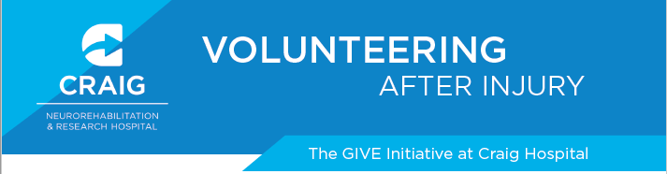
Considerations:
- Interests
- Abilities
- Availability/Commitment
- Transportation
Ways to explore opportunities:

https://www.volunteermatch.org/

https://projecthelping.org/volunteer/

https://www.sparkthechangecolorado.org/volunteer
- Internet searches
  - Local city website for volunteering, churches, schools, libraries, recreation centers
  - Look up any non-profit organizations that may speak to your interests
- Contact Organization
- Ask more questions to assess if the environment, duties, commitment, and schedule match your needs.
Additional Resources:
- Refer to HOPE manual to know your rights as a volunteer and explore potential strategies to help you be successful.
- Contact: giveinitiative@craighospital.org
 …for additional assistance and information on how to get involved.

