

Please help my skin stay peachy by checking boney areas and relieving pressure every
2 hours
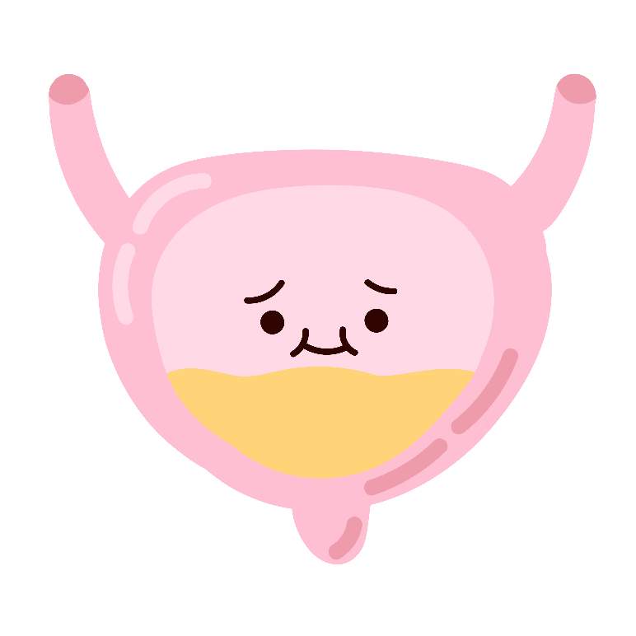

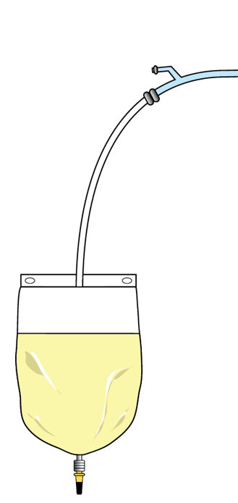

HANG MY PEE LOWER THAN ME
I am unable to feel if my bladder is full and draining properly.
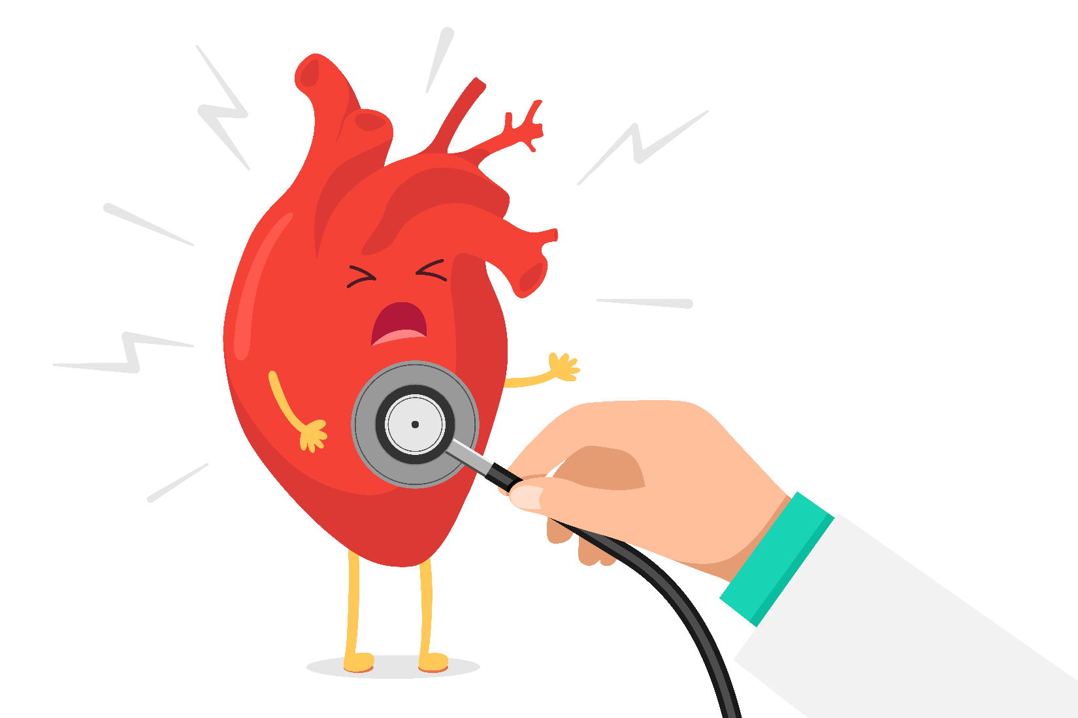

My typical BP is ___________.
If my blood pressure is above _____, I may be experiencing Autonomic Dysreflexia. A potentially life-threatening condition which is an overreaction of my Autonomic Nervous System due to pain stimuli. Please check my bladder, bowels and skin for anything that may be causing this elevation. Removing the pain stimulus will lower my blood pressure to safer levels.

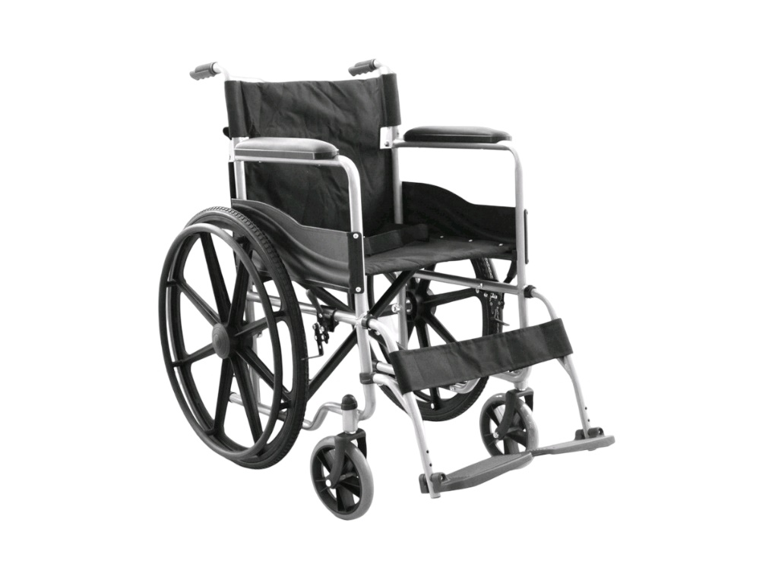
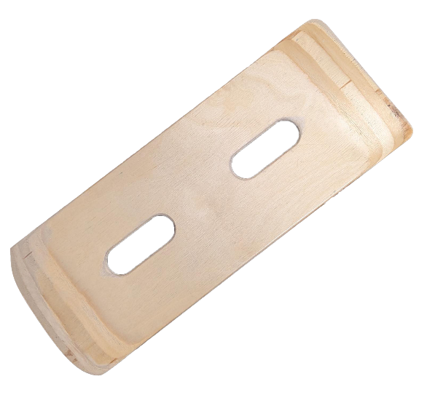

Please do not remove these personal items which aid in my independence from this room. Thank You.
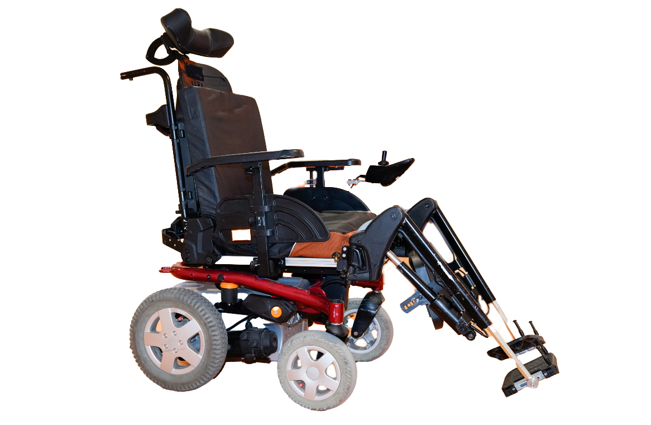

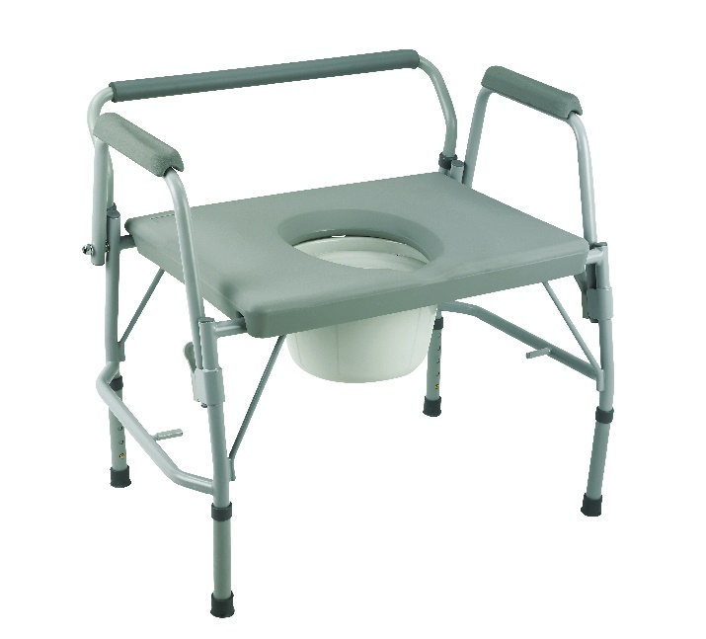

Please do not remove these personal items which aid in my independence from this room. Thank You.


My body has trouble regulating temperature.

-check my room temp
-remove blankets
-recheck in 10 minutes

Edit here

Edit here

Edit here
Edit here

Edit here
Edit here
Edit here

Edit here

